EBOOK LIBRARY “QUOTE”

**PROJECT SYNOPSIS**

OF MAJOR PROJECT

**BACHELORS OF COMPUTER APPLICATION**

SUBMITTED BY

NABA PRASAD BARO

KRITEE DEEPA KALITA

**DEPARTMENT OF COMPUTER SCIENCE**

**RANGIA COLLEGE**

**INDEX**

1. Introduction
2. Objective
3. Scope
4. Features
5. Technology stack
6. Timeline
7. UI
8. Entity relationship diagram

**Introduction**

QUOTE is a vibrant and inclusive online platform designed to bridge the gap between creators and consumers of literature. It provides a comprehensive space for publishers and individual writers to publish a variety of creative works such as books, poems, short stories, one-shots, fanfiction, and more. By offering powerful tools for showcasing content, it empowers writers to share their works with a diverse global audience.

For readers, the platform is more than just a place to read content. It allows them to deeply engage with the works, following their favourite authors and publishers, providing feedback through likes and detailed reviews, and interacting with the creative community. Readers can also collaborate with each other to build shared libraries, creating spaces to exchange views on literature, share personal collections, and discuss authors' works.

The platform aims to foster an environment where creativity and community engagement thrive. It’s not only about discovering new content but also about building meaningful connections between authors and readers and enabling a dialogue that enhances both the writing and reading experiences.

**Objective**

The objective of this platform is to redefine how literature is shared and consumed by offering a seamless experience for both writers and readers.

For writers and publishers, the goal is to provide a user-friendly platform where they can publish their works with ease and reach a wide, engaged audience. The platform supports a variety of creative expressions, from long-form novels to short fanfiction, ensuring a place for every literary genre and style.

For readers, the platform seeks to create a collaborative, interactive experience that goes beyond passive reading. Readers are encouraged to explore new works, follow their favourite authors, and provide meaningful critiques through reviews and likes. By enabling collaborative library creation, readers can not only build collections of their favourite works but also team up with other readers to share literary discoveries and opinions, fostering a shared culture of reading and reflection.

In summary, the platform’s objectives are to:

1. Empower authors and publishers with the tools to publish and promote their works effectively.
2. Enable readers to interact with the literary world through likes, reviews, and personalized libraries.
3. Foster a collaborative environment where readers can share their literary tastes and insights with others.
4. Build a thriving literary community where creativity and interaction drive the platform forward.

**Scope**

The scope of the platform includes providing a space where writers, publishers, and readers can interact in multiple ways:

1. **Content Publishing:** The platform supports the publication of a wide range of creative content, from books and poems to one-shots and fanfiction, allowing writers to reach a global audience.
2. **Reader Engagement:** Readers are not passive consumers but active participants who can follow their favourite authors or publishers, provide reviews and likes, and contribute to discussions about the content they love.
3. **Collaborative Libraries:** Readers have the unique ability to create collaborative libraries with other readers. These libraries allow users to share their interests, insights, and favourite works with friends, making the reading experience a shared journey.
4. **Author & Publisher Interaction:** Writers and publishers have dedicated profiles where they can interact with their readers. They can update followers on new releases, respond to feedback, and build a loyal readership.
5. **Discoverability:** Advanced search and filtering options make it easy for readers to discover new content based on their preferences, whether they are looking for a specific genre, author, or publisher.
6. **Community Features:** The platform fosters a sense of community through features that allow readers and writers to join discussions, participate **in book clubs, and share recommendations.**

**Features**

1. **Content Publishing:** Authors and publishers can upload and publish books, poems, stories, and more, reaching a broad audience.
2. **Reader Interaction:** Readers can engage with content by following their favourite authors, leaving likes, and writing reviews to provide valuable feedback.
3. **Collaborative Libraries:** Readers can create personalized libraries and collaborate with other users to share their interests, favourite works, and insights.
4. **Author & Publisher Profiles:** Writers and publishers can maintain profiles where they can interact with readers, share updates, and showcase their collections.
5. **Advanced Search & Filtering:** Users can easily find content by genre, author, publisher, or specific tags, making discovery of new works effortless.
6. **Community Engagement:** Readers and writers can join discussions, participate in book clubs, and share recommendations within the community.

**Technology Stack**

* **Frontend:** HTML for the user interface, CSS for styling, and JavaScript for responsive design.
* **Backend**: Python 3.11 with Flask framework for the server-side logic.
* **Database:** MYSQL for structured data storage (products, users, orders).
* **Version Control:** Git and GitHub for version control and collaborative development.

**Timeline**

* Phase 1 (First half of Sept): Requirement gathering, system design, and UI/UX.
* Phase 2 (Second half of Sept- first half of Oct): Development of the frontend.
* Phase 3 (Second half of Oct- first half of Nov): Development of backend.
* Phase 4 (Second half of Nov- month of December): Deployment, final testing.

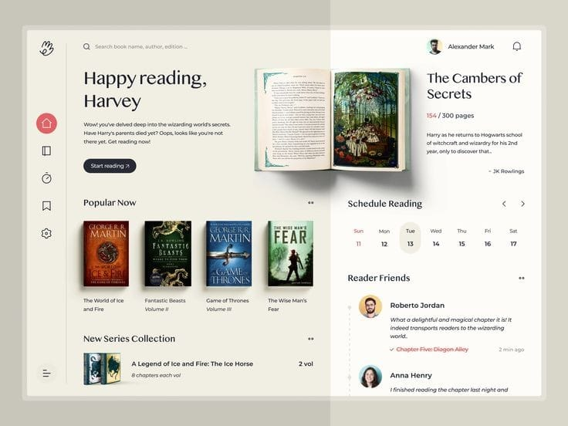**USER INTERFACE**

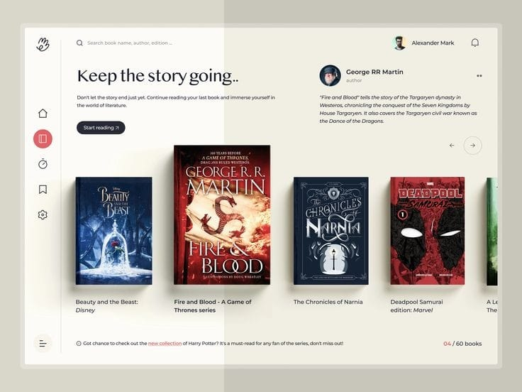

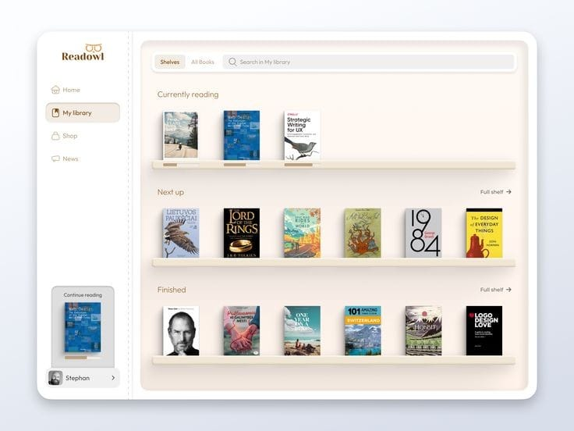

**ER DIAGRAM**

